How to Interpret

Validation Error Notifications Generated by the NIST HL7 V2 Test Tools

Version 1.0

Date: August 19, 2014

**Developed by the National Institute of Standards and Technology (NIST)**

**Document Change History**

|  |  |  |
| --- | --- | --- |
| **Version** | **Description of Change** | **Date** |
| 1.0 | Initial Publication | August 19. 2014 |

**How to Interpret Validation Error Notifications**

**Generated by the NIST HL7 V2 Test Tools**

Table of Contents

1.0 Introduction to the Validation Process and Error Interpretation 6

2.0 Viewing the Validation Error Information 7

3.0 Overview of the Profile Viewer, Vocabulary Page, and Message Content Data Sheet for Error Interpretation 10

3.1 Using the Profile Viewer in the NIST HL7 V2 Test Tools 10

3.2 Using the Vocabulary Page in the NIST HL7 V2 Test Tools 11

3.3 Using the Message Content Data Sheet in the NIST HL7 V2 Test Tools 12

4.0 Reading the Error Notifications in the NIST HL7 V2 Test Tools 14

4.1 Example 1: Reading the “Usage” Error Notification for a “Required” (R) Data Element in the LRI-LIS Context-based Validation or the LRI Context-free Validation 14

4.2 Example 2: Reading the “Data” Error Notification for a “Required, but may be Empty” (RE) Data Element in the LRI-LIS Context-based Validation (Test Data Provided) 16

4.3 Example 3: Reading the “Data” Error Notification for a “Required, but may be Empty” (RE) Data Element in the LRI-LIS Context-based Validation (No Test Data Provided) 19

4.4 Example 4: Reading the “Data” Error Notification for a “Required, but may be Empty” (RE) Data Element in the LRI Context-free Validation (No Vendor-supplied Data Provided) 21

4.5 Example 5: Reading a “Value Not In Table” Error Notification in the LRI-LIS Context-based Validation 22

4.6 Example 6: Reading a “Data” Error Notification in the LRI-LIS Context-based Validation When the Identifier of the Allowable Vocabulary is Incorrect in the Message 24

4.7 Example 7: Reading the “Usage” Error Notification in the LRI-LIS Context-based Validation When a Single “Predicate” Rule Applies 26

4.8 Example 8: Reading a “Usage” Error Notification in the LRI-LIS Context-based Validation or LRI Context-free Validation When Multiple “Predicate” Rules Apply 29

4.9 Example 9: Reading the “Message Structure” Error Notification in the LRI-LIS Context-based Validation or LRI Context-free Validation When a “Conformance Statement” Rule Applies 33

4.10 Example 10: Reading a “Data” Error Notification for Parent-Child Segments in the LRI-LIS Context-based Validation 35

Appendix A 39

Types of Error, Warning, and Alert Notifications Generated by the NIST HL7 V2 Test Tools 39

Glossary 40

Figures

Figure 1. Overview of Validation Process and Interpretation of Errors 6

Figure 2. Example Invalid LRI Message and Message Validation Result 7

Figure 3. Accessing the Message Validation Report 9

Figure 4. Example of a Message Validation Report in PDF 9

Figure 5. Features of the LRI Profile Viewer 11

Figure 6. Features of the LRI Vocabulary Page 12

Figure 7. Features of the Message Content Data Sheet 13

Figure 8. Test Data Categorization and Validation 13

Figure 9. How an "R" Usage Type Error is Displayed: Message Validation Result and Message Validation Report 14

Figure 10. Using the LRI Profile Viewer to Look Up the Usage for an "R" Data Element 15

Figure 11. How an "RE" Data Type Error is Displayed: Message Validation Result and Message Validation Report 16

Figure 12. Using the LRI Profile Viewer to Look Up the Usage for an "RE" Data Element 17

Figure 13. Message Content Data Sheet Showing Race-Alternate Identifier Test Data Provided 18

Figure 14. How No "RE" Data (Usage) Type Error is Displayed: Message Validation Result and Message Validation Report 19

Figure 15. Message Content Data Sheet Showing Race-Alternate Identifier Test Data Are Not Provided 20

Figure 16. No "RE" Data (Usage) Type Error is Displayed: Message Validation Result and Message Validation Report 21

Figure 17. "Value Not in Table" Type Error is Displayed: Message Validation Result and Message Validation Report 22

Figure 18. Using the LRI Vocabulary Page to Look Up the Value Codes for Table 0001 23

Figure 19. "Data" Type Error for Vocabulary ID is Displayed: Message Validation Result and Message Validation Report 24

Figure 20. Using the LRI Profile Viewer to Look Up the Allowable Vocabulary for SPM.24 25

Figure 21. "Usage" Type Error is Displayed for Invalid Predicate Conformance: Message Validation Result and Message Validation Report 26

Figure 22. Using the LRI Profile Viewer to Look Up the Predicate, Table, and Usage for a Missing Data Element 28

Figure 23. Using the LRI Vocabulary Page to Look Up the Value Codes for Table 0125 28

Figure 24. Message Content Data Sheet Showing the "NM" Value Type as Test Case Fixed Data for OBX.2 28

Figure 25. "Usage" Type Error is Displayed for Complex Invalid Predicate Conformance: Message Validation Result 29

Figure 26. Using the LRI Profile Viewer to Look Up the Predicate, Table, and Usage for OBX.2, OBX.6, and OBX.11 30

Figure 27. Using the LRI Vocabulary Page to Look Up the Value Codes for Table 0085 31

Figure 28. Message Content Data Sheet Showing the "CWE" Value Type as Test Fixed Data for OBX.2 (Not Applicable for Context-free Validation) 31

Figure 29. Using the LRI Vocabulary Page to Look Up the Value Codes for Table 0125 32

Figure 30. "Message Structure" Type Error is Displayed for Invalid Conformance: Message Validation Result and Message Validation Report 33

Figure 31. Using the LRI Profile Viewer to Look Up the Conformance Statements for Misaligned Data Elements 34

Figure 32. "Data" Type Parent-Child Segment Error is Displayed: Message Validation Result and Message Validation Report 35

Figure 33. Invalid Version of Message with Parent-Child Segments Misaligned 37

Figure 34. Corrected Version of Message with Parent-Child Segments Aligned 38

Tables

Table 1. Illustration of PID Data Elements with Components and Sub-components 8

Table 2. Applying the Location Format for PID[1].3[2].4.1 8

Table 3. Comparison: Message Validation Result vs. Report for "R" Usage Error in LRI Test Tool 15

Table 4. Comparison: Message Validation Result vs. Report for "RE" Usage Error in LRI Test Tool 17

Table 5. Comparison: Message Validation Result vs. Report for "Value Not in Table” Error in LRI Test Tool 22

Table 6. Comparison: Message Validation Result vs. Report for "Data (Table)” Error in LRI Test Tool 24

Table 7. Comparison: Message Validation Result vs. Report for "Usage” and “Data” Errors in LRI Test Tool Related to a Predicate 27

Table 8. Comparison: Message Validation Result vs. Report for "Parent-Child Data” Errors in LRI Test Tool 36

# Introduction to the Validation Process and Error Interpretation

When a NIST HL7 V2 Test Tool validates a test message, the test tool will produce error notifications to indicate where the message is non-conformant to the conformance profile as defined by the particular implementation/messaging guide. **Figure 1** provides an overview of the validation process and the features available within the NIST Test Tools to assist the user with interpretation and correction of errors in a test message.

Figure 1. Overview of Validation Process and Interpretation of Errors

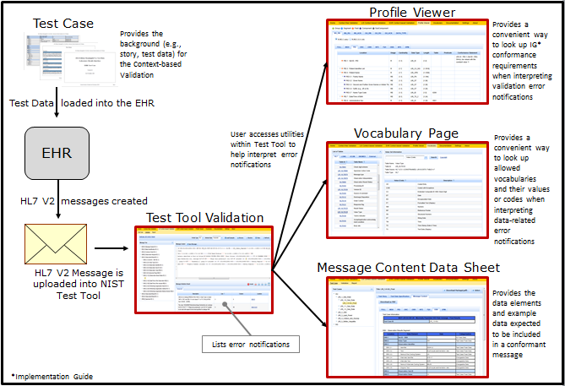

Subsequent sections in this document provide additional details about how to use these features when interpreting specific error notifications.

# Viewing the Validation Error Information

The error notifications generated by the NIST HL7 V2 Test Tools are displayed immediately in the **Message Validation Result** section of the Validation window in the test tool, and they also are listed in the **Message Validation Report**.

**Figure 2** shows the Validation window in which an example invalid Lab Result Interface (LRI) message displays in the Message Content section, and the associated errors display in the Message Validation Result section.

Figure 2. Example Invalid LRI Message and Message Validation Result

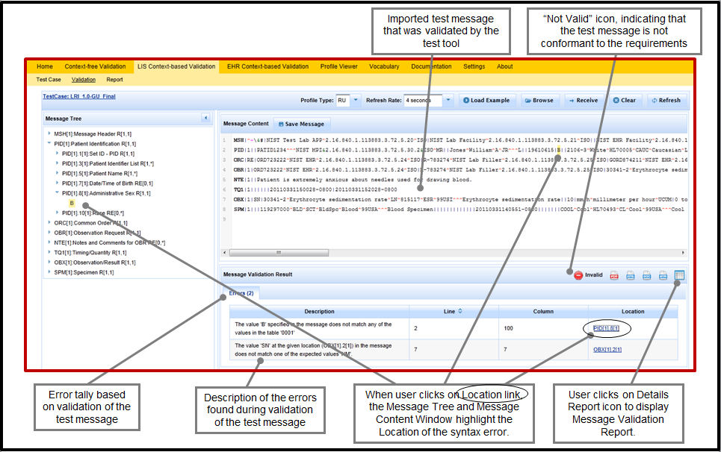

The Location format for the information provided in an error notification is “SSS[n1].N1[n2].N2.N3”. An example would be “OBX[6].5[2].1”, which indicates that the Location of the error is (reading the notation backwards) in the first component of the second instance of the fifth data element field in the sixth OBX segment in the message.

To explain further, **Table 1** shows examples of data elements, components, and sub-components from a PID segment; and **Table 2** illustrates how the Location format would be applied if the error occurred in the first sub-component of the fourth component of the second instance of the third data element field of the first PID segment in a message – which would appear as “PID[1].3[2].4.1”. (The error notification Location format always includes data in the [ ] even when there is only one instance of the segment in the message or only one instance of the data element in the segment.)

Table 1. Illustration of PID Data Elements with Components and Sub-components

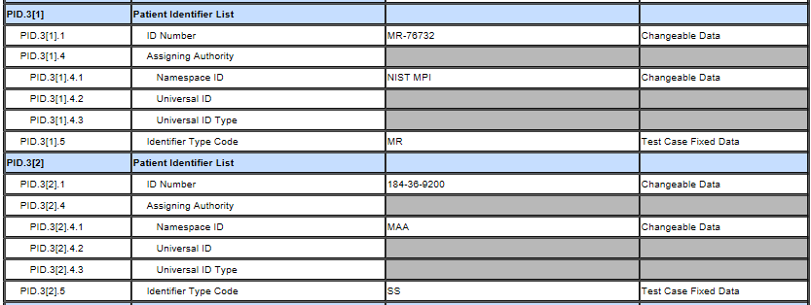

Table 2. Applying the Location Format for PID[1].3[2].4.1

| **Format** | **Format Description** | **Example** | **Example Description** |
| --- | --- | --- | --- |
| SSS | The Segment ID | PID | The PID Segment |
| [n1] | The instance of the segment in the message | [1] | The 1st instance of the PID segment in the message |
| .N1 | The position # for the data element field in the segment | .3 | The 3rd data element field in this PID segment |
| [n2] | The instance of the data element field in the segment | [2] | The 2nd instance of the 3rd data element field in this PID segment |
| .N2 | The component of the data element in the segment | .4 | The 4th component of the 3rd data element in this PID segment |
| .N3 | The sub-component of the data element in the segment | .1 | The 1st sub-component of the 4th component of the 3rd data element in this PID segment |

The Message Validation Report, which is accessible from the Validation window, provides additional information about each error notification. **Figure 3** shows how to access, print, and download this report.

**Figure 4** shows an example of a PDF version of the Message Validation Report. The various sections of the report provide key information:

1. The name and version number of the Test Tool
2. Details about the Test Case for which the test message was produced, including the Test Case ID and the description of the Test Story for the Test Case
3. Information about the HL7 profile against which the message was validated (e.g., Profile name, type, version and date)
4. A copy of the message that was imported into and validated by the Test Tool
5. A summary showing the tally of Errors, Warnings, and Alerts for the validated message
6. A list of the Validation Errors with details indicating for each error the Type, Description, Location; and, as appropriate, the Element Content
7. A list of the Validation Alerts with details indicating for each alert the Type and Description

Figure 3. Accessing the Message Validation Report

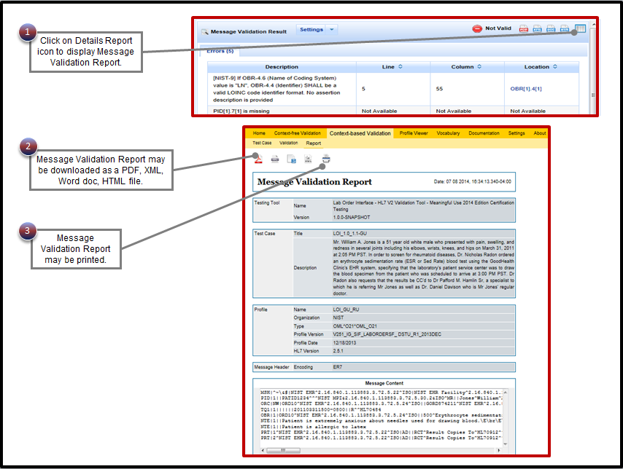

Figure 4. Example of a Message Validation Report in PDF

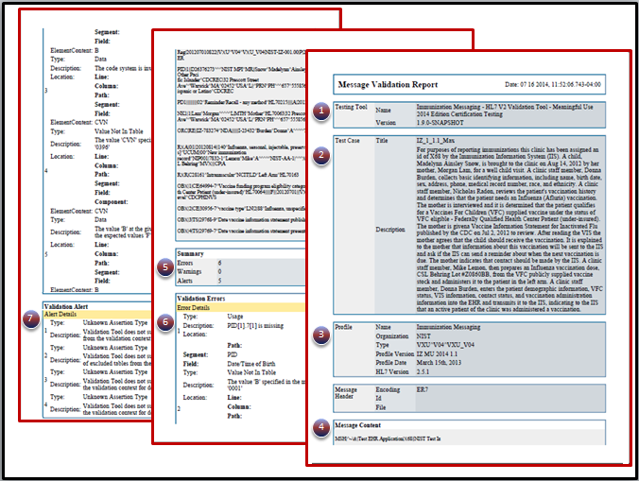

# Overview of the Profile Viewer, Vocabulary Page, and Message Content Data Sheet for Error Interpretation

The NIST HL7 V2 Test Tools include several features that assist the user with efficient interpretation of the error notifications generated from message validation, including the Profile Viewer, Vocabulary page, and Message Content Data Sheet.

Subsections 3.1, 3.2, and 3.3 in this document provide details about each one of these features.

## Using the Profile Viewer in the NIST HL7 V2 Test Tools

The Profile Viewer is a feature that provides a convenient way for a user to look up the conformance requirements for each data element. The conformance requirements are:

* Usage
* Cardinality
* Data Type
* Length
* Allowed vocabulary (listed in the “Table” column)
* Condition Predicate
* Conformance Statement

This feature is helpful when error notifications are generated by the test tool for the following types of errors:

* Missing data due to a Usage requirement
* Missing data due to non-conformance to a Predicate requirement
* Wrong data due to use of an invalid allowable vocabulary (Wrong Table)
* Invalid Message Structure according to a Conformance Statement.

The format of the Profile Viewer page differs only slightly from one NIST HL7 V2 Test Tool to another in order to accommodate the different conformance requirements.

**Figure 5** highlights the features of the Profile Viewer page in the LRI Test Tool:

1. The user accesses this utility by clicking on “Profile Viewer” in the Menu Bar
2. To display the correct values, the user clicks on the tab for the particular LRI conformance profile declared by the EHR technology and used for the test messages
3. The user selects the Usage indicator
   * R, RE, C (Only) to view only “Required”, “Required but may be empty” and “Conditional” elements
   * R, RE, C, O, X (All) to view all data elements, including optional and not supported elements
4. The user selects the desired Segment tab and looks for the exact data element by Location indicator (e.g., PID.10)

The user may check the following information for the data element

1. Usage
2. Cardinality
3. Data Type
4. Length
5. Table
6. Predicate
7. Conformance Statement

Figure 5. Features of the LRI Profile Viewer

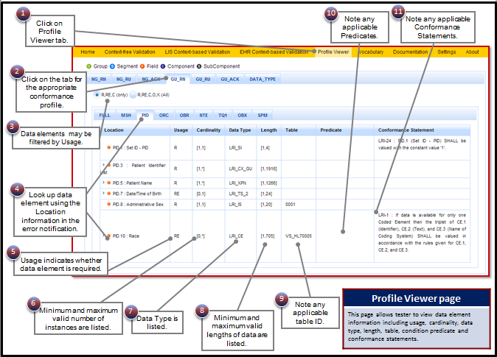

## Using the Vocabulary Page in the NIST HL7 V2 Test Tools

The Vocabulary page is a feature that provides a convenient way for a user to look up the valid vocabulary values that are included in a table that is listed for a data element in the Profile Viewer (see #9 in **Figure 5**). This feature is helpful when a user needs to understand why an error notification related to an invalid vocabulary value is generated by the test tool. The format of the Vocabulary page differs slightly from one NIST HL7 V2 Test Tool to another in order to accommodate the different vocabulary conformance requirements.

**Figure 6** highlights the features of the Vocabulary page in the LRI Test Tool:

1. The user accesses this utility by clicking on “Vocabulary” in the Menu Bar
2. To display the specific table, the user clicks on the tab to select the vocabulary domain ( e.g. HL7 internal table vs SNOMED CT).
3. The user selects the Table ID from the list of tables displayed by the table tab
4. The valid values for the selected table display to the user
5. The user may use the Search box to search for a value code, value set, table name, table ID, or description

Figure 6. Features of the LRI Vocabulary Page

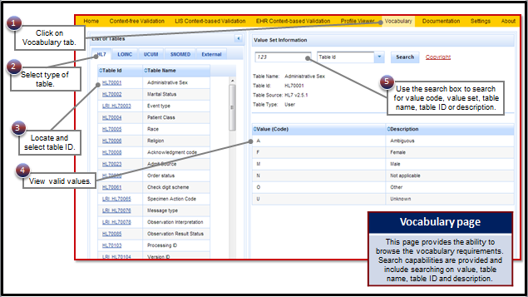

## Using the Message Content Data Sheet in the NIST HL7 V2 Test Tools

A Message Content Data Sheet is available for each Test Case in the Context-based Validation function of the NIST HL7 V2 Test Tools, and it is the “answer sheet” that corresponds to the example valid test message associated with a Test Case. **Figure 7** highlights the features of the Message Content Data Sheet in the LRI Test Tool.

1. The user accesses the Message Content Data Sheet by selecting a Test Case and then clicking on the “Message Content” tab
2. To display the specific segment, the user clicks on the tab for the segment they want to view
3. The user scrolls down to find the Location and name of the desired data element
4. The user views the test data provided for the data element (a greyed-out, empty cell in the Data column indicates no test data are provided.)
5. The user views the category assigned to the data element (see **Figure 8** for further description of data categorization)

Figure 7. Features of the Message Content Data Sheet

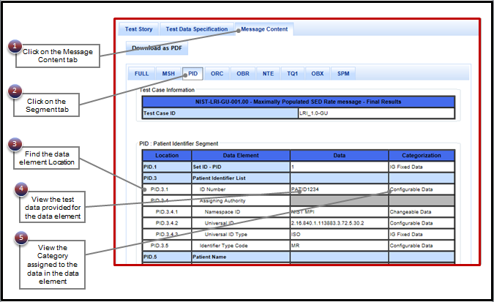

The data element categorization is determined by NIST for each data element. **Figure 8** lists the five categories, the description of each category, and the validation action performed by the test tool for each category.

Figure 8. Test Data Categorization and Validation

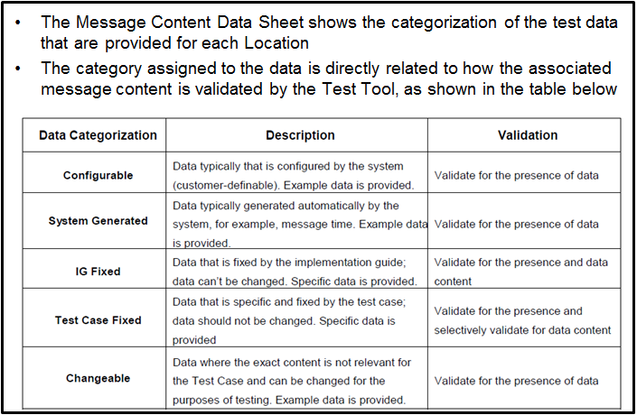

# Reading the Error Notifications in the NIST HL7 V2 Test Tools

Error notifications are generated by the NIST HL7 V2 test tools for several types of issues that may be found when an invalid message is evaluated, including:

|  |  |
| --- | --- |
| * Usage * Data * Datatype * Message Structure | * Value Not In Table * Predicate * Conformance Statement |

See Appendix A for a list of notification types and their definitions.

## Example 1: Reading the “Usage” Error Notification for a “Required” (R) Data Element in the LRI-LIS Context-based Validation or the LRI Context-free Validation

**Figure 9** shows an example of how the LIS Context-based Validation and LRI Context-free Validation display error notification information for an invalid LRI message that is missing data for a data element with Usage “Required” (i.e., Usage = R).

Figure 9. How an "R" Usage Type Error is Displayed: Message Validation Result and Message Validation Report

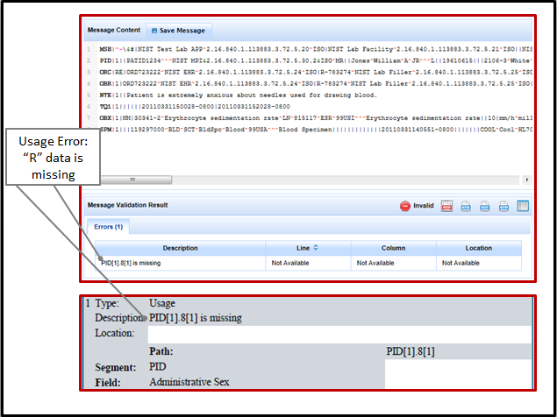

The error notification displays in the Message Validation Result window and on the Message Validation Report; however, the information provided in the Result versus the Report differs slightly, as shown in **Table 3**.

Table 3. Comparison: Message Validation Result vs. Report for "R" Usage Error in LRI Test Tool

|  |  |  |  |
| --- | --- | --- | --- |
| **Message Validation Result** | | **Message Validation Report** | |
|  |  | Type | Usage |
| Description | PID[1].8[1] is missing | Description | PID[1].8[1] is missing |
| Line | Not Available |  |  |
| Column | Not Available |  |  |
| Location | Not Available | Location |  |
|  |  | Path | PID[1].8[1] |
|  |  | Segment | PID |
|  |  | Field | Administrative Sex |

From the information provided in the Message Validation Result and the Message Validation Report, the user can see that the Administrative Sex data value is missing from the PID segment in the message, and that this data value is supposed to populate the PID.8 Location.

Neither the Message Validation Result nor the Message Validation Report provides the actual Usage for the missing data element, so the user should open the Profile Viewer to determine the Usage for that data element. **Figure 10** illustrates how the LRI Profile Viewer would be used to look up this information for this error when the system under test (SUT) declares conformance to the LRI GU_RU Profile.

Figure 10. Using the LRI Profile Viewer to Look Up the Usage for an "R" Data Element

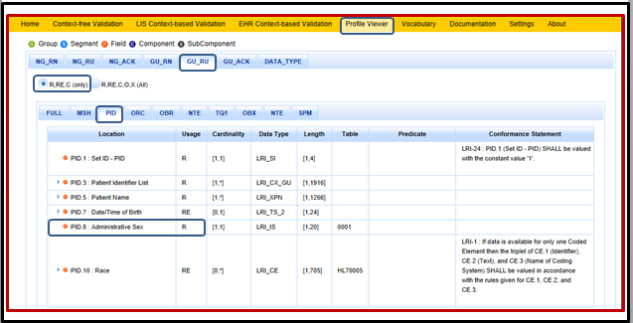

## Example 2: Reading the “Data” Error Notification for a “Required, but may be Empty” (RE) Data Element in the LRI-LIS Context-based Validation (Test Data Provided)

When test data are provided for an “RE” data element in a Test Case and LIS Context-based Validation is used to evaluate the test message, the SUT will be tested for the ability to create a test message that includes data for that data element.

**Figure 11** shows an example of how the LIS Context-based Validation displays error notification information for an invalid LRI message that is missing data for a data element with Usage “Required, but may be empty” (i.e., Usage = RE) *when test data for this data element are provided*.

Figure 11. How an "RE" Data Type Error is Displayed: Message Validation Result and Message Validation Report

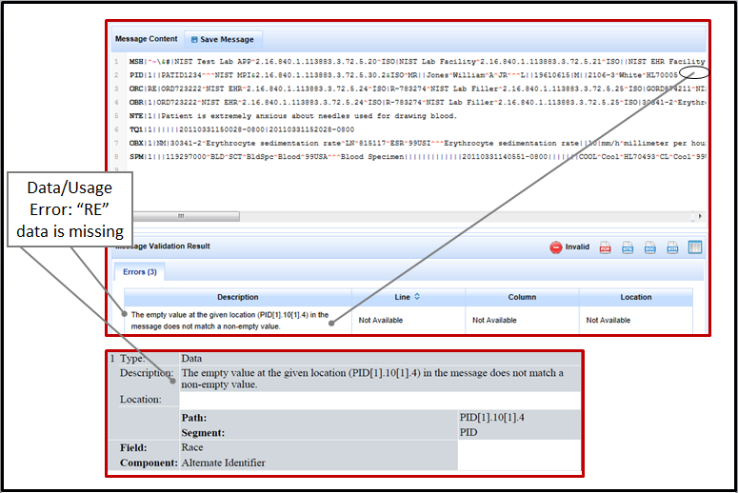

The error notification displays in the Message Validation Result window and on the Message Validation Report; however, the information provided in the Result versus the Report differs slightly, as shown in **Table 4**.

Table 4. Comparison: Message Validation Result vs. Report for "RE" Usage Error in LRI Test Tool

| **Message Validation Result** | | **Message Validation Report** | |
| --- | --- | --- | --- |
|  |  | Type | Data |
| Description | The empty value at the given location (PID[1].10[1].4 in the message does not match a non-empty value. | Description | The empty value at the given location (PID[1].10[1].4 in the message does not match a non-empty value. |
| Line | Not Available |  |  |
| Column | Not Available |  |  |
| Location | Not Available | Location |  |
|  |  | Path | PID[1].10[1].4 |
|  |  | Segment | PID |
|  |  | Field | Race |
|  |  | Component | Alternate Identifier |

From the information provided in the Message Validation Result and the Message Validation Report, the user can see that the Alternate Identifier data value for Race is missing from the PID segment in the message, and that this data value is supposed to populate the PID.10.4 Location.

Neither the Message Validation Result nor the Message Validation Report provides the actual Usage for this data element that is missing, so the user should open the Profile Viewer to determine the Usage for that data element. **Figure 12** illustrates how the LRI Profile Viewer would be used to look up this information for this error when the SUT declares conformance to LRI GU_RU Profile.

Figure 12. Using the LRI Profile Viewer to Look Up the Usage for an "RE" Data Element

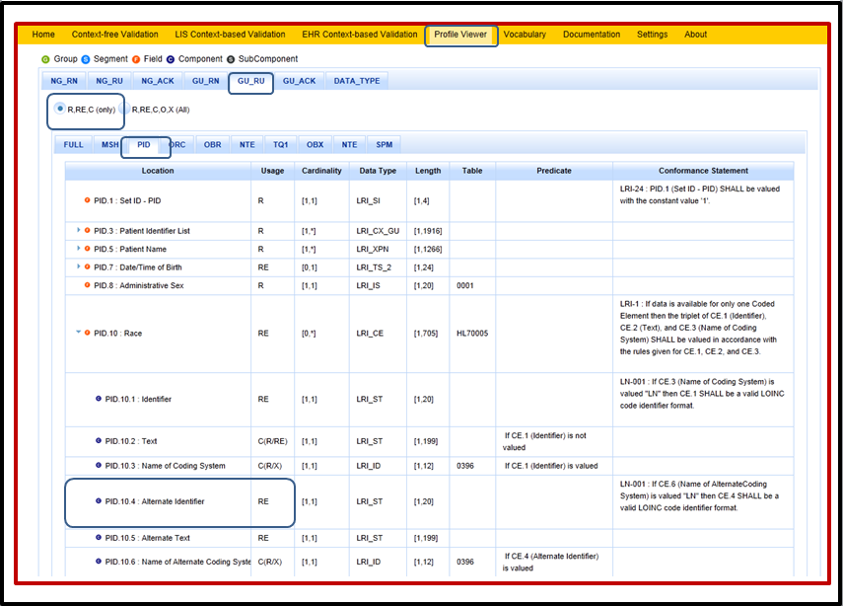

As shown in the Profile Viewer, the data element Usage is RE, meaning the data element is required, but if the data for the data element is *not known* the Location may be empty in the HL7 message; however, for *capability/conformance testing*, *if test data are provided for this data element*, then the data are *known* and the Location in the HL7 message MUST be populated. Conversely, if no data are present for this data element in the Message Content Data Sheet, then no error notification would be generated by the testing tool if the element is empty in the message. In Context-free Validation also, no error notification would be generated by the testing tool if the element is empty in the message.

To determine if test data are provided for the data element, the user should access the Message Content Data Sheet for the Test Case. **Figure 13** shows an excerpt from the Message Content Data Sheet containing the relevant information for this example error notification.

Figure 13. Message Content Data Sheet Showing Race-Alternate Identifier Test Data Provided

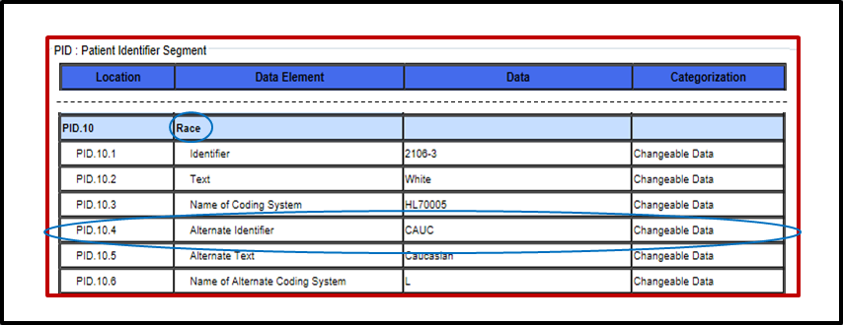

## Example 3: Reading the “Data” Error Notification for a “Required, but may be Empty” (RE) Data Element in the LRI-LIS Context-based Validation (No Test Data Provided)

**Figure 14** shows an example of how the LIS Context-based Validation displays no error notification information for an LRI message that is missing data for a data element with Usage “Required, but may be empty” (i.e., Usage = RE) *when no test data for this data element are provided*.

Figure 14. How No "RE" Data (Usage) Type Error is Displayed: Message Validation Result and Message Validation Report

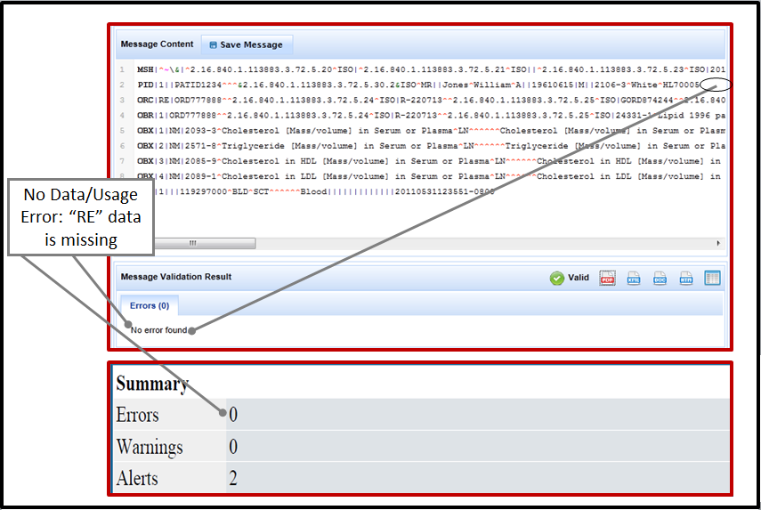

No “Data (Usage)” error notification displays in the Message Validation Result window or on the Message Validation Report, so the user likely would not open the Profile Viewer to view Usage information.

To determine if test data are provided for the data element, the user should access the Message Content Data Sheet for the Test Case. **Figure 15** shows an excerpt from the Message Content Data Sheet containing the relevant information for this example error notification.

Figure 15. Message Content Data Sheet Showing Race-Alternate Identifier Test Data Are Not Provided

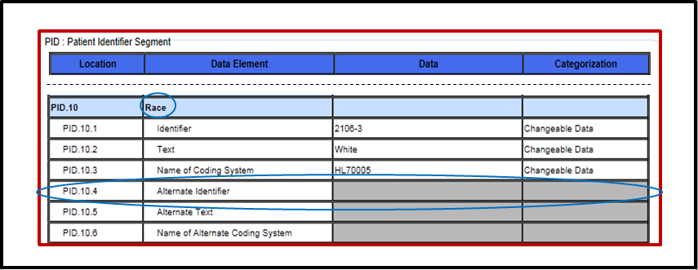

## Example 4: Reading the “Data” Error Notification for a “Required, but may be Empty” (RE) Data Element in the LRI Context-free Validation (No Vendor-supplied Data Provided)

**Figure 16** shows an example of how the LRI Context-free Validation displays no error notification information for an LRI message that is missing data for a data element with Usage “Required, but may be empty” (i.e., Usage = RE) *when no Vendor-supplied data for this data element is provided*.

No error notification displays in the Message Validation Result window or on the Message Validation Report indicating that data are *missing* for an “RE” data element, because the test tool has no context against which to validate the message. The user likely would not open the Profile Viewer to view the Usage for this data element, and no Message Content Data Sheet exists for a context-free message.

Figure 16. No "RE" Data (Usage) Type Error is Displayed: Message Validation Result and Message Validation Report

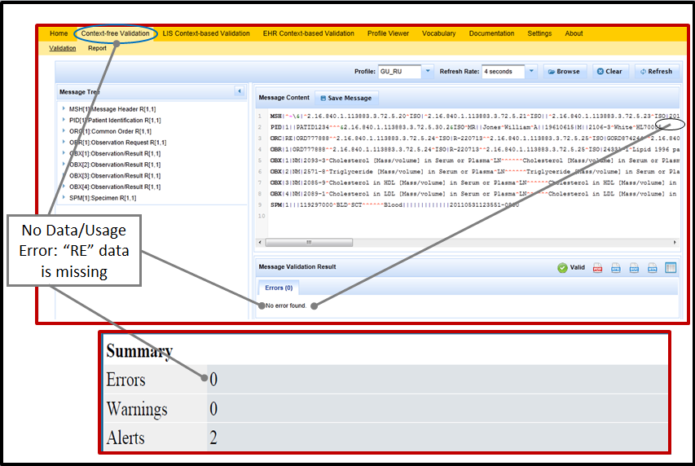

## Example 5: Reading a “Value Not In Table” Error Notification in the LRI-LIS Context-based Validation

**Figure 17** shows an example of how the LIS Context-based Validation displays error notification information for an invalid LRI message that includes a value code not listed in the table specified by the implementation/messaging guide for the data element.

Figure 17. "Value Not in Table" Type Error is Displayed: Message Validation Result and Message Validation Report

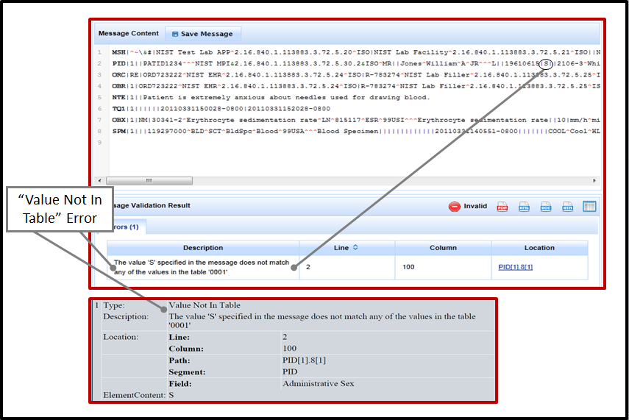

The error notification displays in the Message Validation Result window and on the Message Validation Report; however, the information provided in the Result versus the Report differs slightly, as shown in **Table 5**.

Table 5. Comparison: Message Validation Result vs. Report for "Value Not in Table” Error in LRI Test Tool

| **Message Validation Result** | | **Message Validation Report** | |
| --- | --- | --- | --- |
|  |  | Type | Value Not In Table |
| Description | The value 'S' specified in the message does not match any of the values in the table '0001' | Description | The value 'S' specified in the message does not match any of the values in the table '0001' |
| Location | PID[1].8[1] | Location |  |
| Line | 2 | Line | 2 |
| Column | 100 | Column | 100 |
|  |  | Path | PID[1].8[1] |
|  |  | Segment | PID |
|  |  | Field | Administrative Sex |
|  |  | Element Content | S |

From the information provided in the Message Validation Result and the Message Validation Report, the user can see that the content “S” at Location PID.8 (Administrative Sex) in the message is not in table 0001.

To determine the valid value codes to use for PID.8, the user should go to the Vocabulary page and look up “table 0001” as “HL70001” under the vocabulary domain tab “HL7” (“0001” is the name of this table used in the error notification and in the Profile Viewer, and “HL70001” is the name used on the Vocabulary page). **Figure 18** illustrates how the LRI Vocabulary page would be used to look up this information.

Figure 18. Using the LRI Vocabulary Page to Look Up the Value Codes for Table 0001

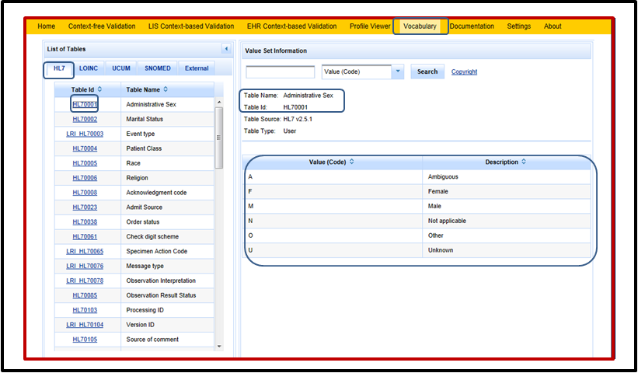

## Example 6: Reading a “Data” Error Notification in the LRI-LIS Context-based Validation When the Identifier of the Allowable Vocabulary is Incorrect in the Message

**Figure 19** shows an example of how the LIS Context-based Validation displays error notification information for an LRI message that includes an invalid identifier for an allowable vocabulary for a coded data element.

Figure 19. "Data" Type Error for Vocabulary ID is Displayed: Message Validation Result and Message Validation Report

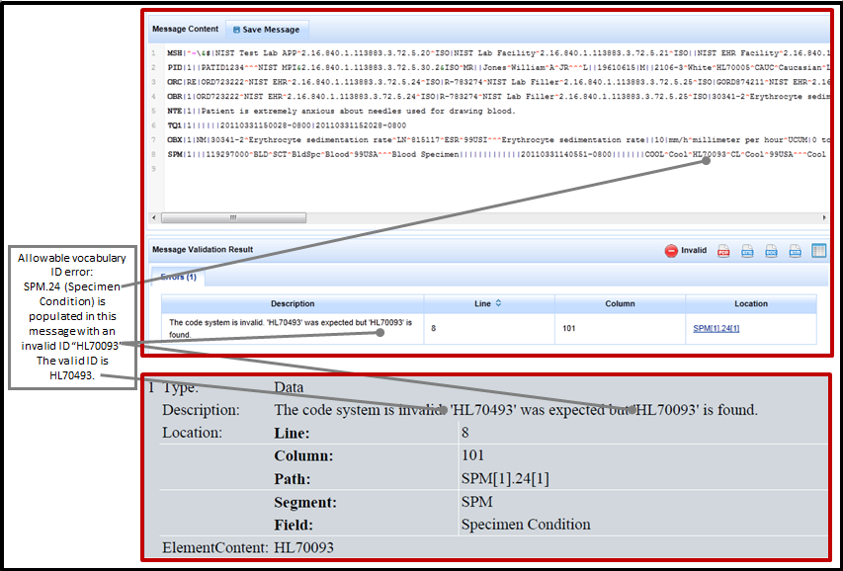

The error notification displays in the Message Validation Result window and on the Message Validation Report; however, the information provided in the Result versus the Report differs slightly, as shown in **Table 6**.

Table 6. Comparison: Message Validation Result vs. Report for "Data (Table)” Error in LRI Test Tool

| **Message Validation Result** | | **Message Validation Report** | |
| --- | --- | --- | --- |
|  |  | Type | Data |
| Description | The code system is invalid. ‘HL70493’ was expected but ‘HL70093’ is found | Description | The code system is invalid. ‘HL70493’ was expected but ‘HL70093’ is found |
| Location | SPM[1].24[1] | Location |  |
| Line | 8 | Line | 8 |
| Column | 101 | Column | 101 |
|  |  | Path | SPM[1].24[1] |
|  |  | Segment | SPM |
|  |  | Field | Specimen Condition |
|  |  | Element Content | HL70093 |

From the information provided in the Message Validation Result and the Message Validation Report, the user can see that “HL70093” at Location SPM.24 (Specimen Condition) in the message should have been “HL70493”.

To determine the allowable vocabulary to use for an element, the user should go to the LRI Profile Viewer and look up this information in the “Table” column for SPM.24. **Figure 20** illustrates how the LRI Profile Viewer would be used to look up this information.

Figure 20. Using the LRI Profile Viewer to Look Up the Allowable Vocabulary for SPM.24

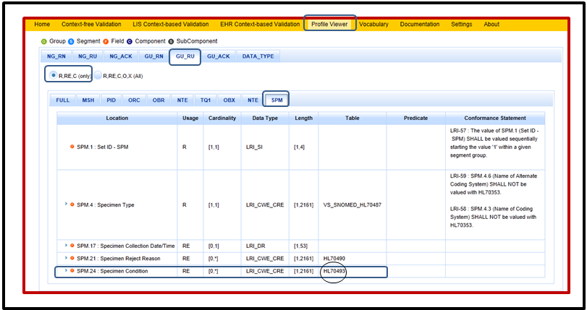

## Example 7: Reading the “Usage” Error Notification in the LRI-LIS Context-based Validation When a Single “Predicate” Rule Applies

**Figure 21** shows an example of how the LIS Context-based Validation displays error notification information for an LRI GU_RN Profile message that is invalid because it does not include a value that is required according to a Predicate specification. In this example, OBX.5 is populated with a numeric value of “10”. The Predicate states that if OBX.5 is populated with a value, then OBX.2 must be populated.

Figure 21. "Usage" Type Error is Displayed for Invalid Predicate Conformance: Message Validation Result and Message Validation Report

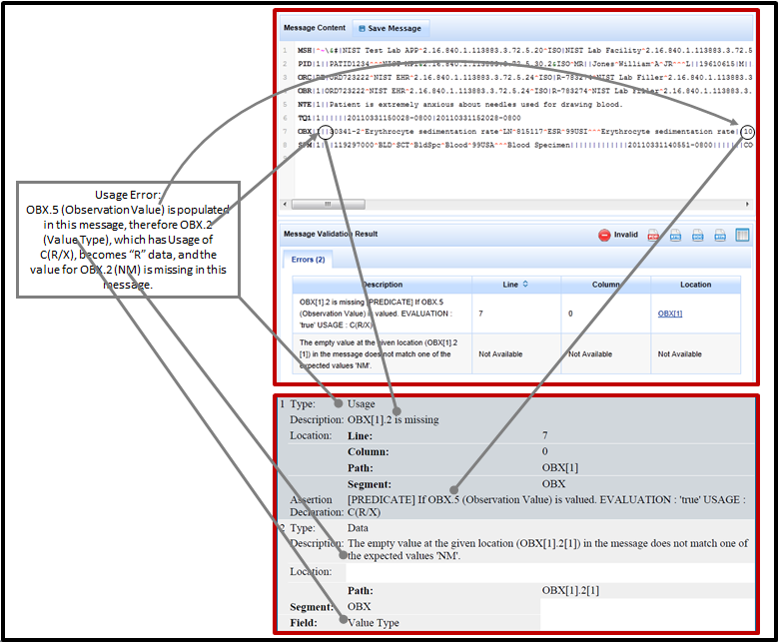

The error notifications display in the Message Validation Result window and on the Message Validation Report; however, the information provided in the Result versus the Report differs slightly, as shown in **Table 7**.

Table 7. Comparison: Message Validation Result vs. Report for "Usage” and “Data” Errors in LRI Test Tool Related to a Predicate

| **Message Validation Result** | | **Message Validation Report** | |
| --- | --- | --- | --- |
|  |  | Type | Usage |
| Description | OBX[1].2 is missing [PREDICATE] If OBX.5 (Observation Value) is valued. EVALUATION: 'true' USAGE: C(R/X) | Description | OBX[1].2 is missing |
| Location | OBX[1] | Location |  |
| Line | 7 | Line | 7 |
| Column | 0 | Column | 0 |
|  |  | Path | OBX[1] |
|  |  | Segment | OBX |
|  |  | Assertion Declaration | [PREDICATE] If OBX.5 (Observation Value) is valued. EVALUATION : 'true' USAGE: C(R/X) |
| **Message Validation Result** | | **Message Validation Report** | |
|  |  | Type | Data |
| Description | The empty value at the given location (OBX[1].2[1]) in the message does not match one of the expected values 'NM'. | Description | The empty value at the given location (OBX[1].2[1]) in the message does not match one of the expected values 'NM'. |
| Location | Unavailable | Location |  |
| Line | Unavailable |  |  |
| Column | Unavailable |  |  |
|  |  | Path | OBX[1].2[1] |
|  |  | Segment | OBX |
|  |  | Field | Value Type |

From the information provided in the Message Validation Result and the Message Validation Report, the user can see that

* The data value at Location OBX.2 in the first OBX segment in the message is missing based on a [PREDICATE] requirement that states if OBX.5 (Observation Value) is populated then the conditional requirement for OBX.2 becomes “R”, meaning Required
* The expected value for OBX.2 is “NM”

To further research the information in these error notifications, the user should open the Profile Viewer to find the Predicate, Table, and Usage for the OBX.2 data element. **Figure 22** illustrates how the LRI Profile Viewer would be used to look up this information for this error when the SUT declares conformance to LRI GU_RU Profile.

The Predicate states “If OBX.5 (Observation Value) is valued” (i.e., if the OBX.5 field is populated), then the conditional Usage of C(R/X) – i.e., Usage is Required if OBX.5 is populated, and Usage is Exclude if OBX.5 is not populated – becomes Required.

Table 0125 is designated as the table to use to find the valid values for populating OBX.2 (Value Type).

**Figure 23** illustrates how the LRI Vocabulary page would be used to look up this information, and shows “NM” as one of the valid values. **Figure 24** shows the Message Content Data Sheet for this test case where the user would find that “NM” is Test Case Fixed Data provided in the test data for the OBX.2 data element.

Figure 22. Using the LRI Profile Viewer to Look Up the Predicate, Table, and Usage for a Missing Data Element

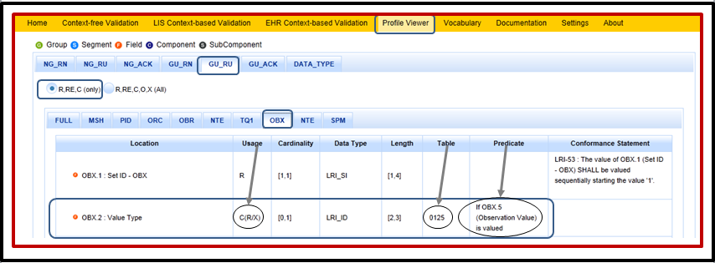

Figure 23. Using the LRI Vocabulary Page to Look Up the Value Codes for Table 0125

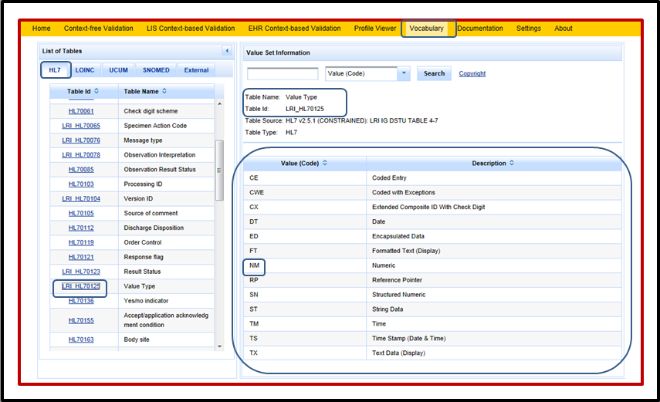

Figure 24. Message Content Data Sheet Showing the "NM" Value Type as Test Case Fixed Data for OBX.2

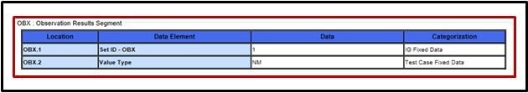

## Example 8: Reading a “Usage” Error Notification in the LRI-LIS Context-based Validation or LRI Context-free Validation When Multiple “Predicate” Rules Apply

**Figure 25** shows an example of how the LIS Context-based Validation and LRI Context-free Validation display error notification information for an LRI GU_RU Profile message that is invalid because of a more complex Predicate specification. Note that OBX[1].11[1] is “P”, shown highlighted in the Message Tree and the Message Content window.

Figure 25. "Usage" Type Error is Displayed for Complex Invalid Predicate Conformance: Message Validation Result

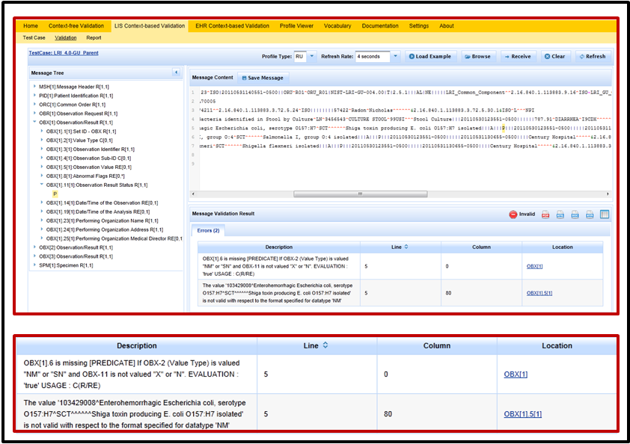

In this example of an invalid LRI message,

* OBX.2 (Value Type) in the first OBX segment of the message is populated with “NM”
* OBX.5 (Observation Value) in the first OBX segment of the message is populated with a coded value of “103429008^Enterohemorrhagic Escherichia coli, serotype O157:H7^SCT^^^^^^Shiga toxin producing E. coli O157:H7 isolated”
* OBX.11 (Observation Result Status) in the first OBX segment of the message is populated with “P” for Preliminary Results
* OBX.6 (Units) in the first OBX segment of the message is unpopulated

The first of the two error notifications is telling the user the Predicate states that OBX.6 (Units) Usage is “R” if OBX-2 (Value Type) is populated with "NM" or "SN" and if OBX-11 is not populated with an "X" or an "N"; but OBX.6 in the first OBX segment of the message is not populated even though OBX.2 in that segment is “NM” and OBX.11 is “P”.

The second error notification is telling the user that OBX.5 does not follow the “NM” format, because the content in OBX.5 is not numeric data; rather, this content is “103429008^Enterohemorrhagic Escherichia coli, serotype O157:H7^SCT^^^^^^Shiga toxin producing E. coli O157:H7 isolated”, which is coded data.

**Figure 26** shows how the user would use the Profile Viewer to look up the Predicate information for OBX.2 and OBX.6; the Table information for OBX.2 and OBX.11; and the Usage information for OBX.2, OBX.6, and OBX.11.

**Figure 27** shows how the user would use the Vocabulary page to look up the allowed vocabulary information for OBX.11.

**Figure 28** shows the Message Content Data Sheet for this test case where the user would find that “CWE” is Test Case Fixed Data provided in the test data for the OBX.2 data element. Note: no Message Content Data Sheet is provided for Context-free Validation.

**Figure 29** shows how the user would use the Vocabulary page to look up the allowed vocabulary information for OBX.2.

Example 8 illustrates one among many situations in which multiple error notifications are triggered, and by fixing the content in one Location of the message (in this case changing the data value in OBX.2 to “CWE”) the other error also is resolved.

Figure 26. Using the LRI Profile Viewer to Look Up the Predicate, Table, and Usage for OBX.2, OBX.6, and OBX.11

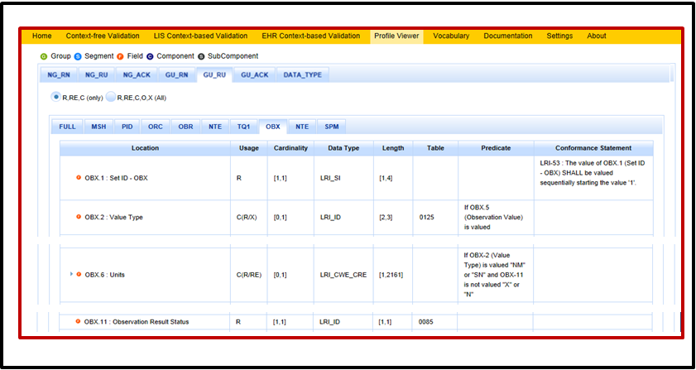

Figure 27. Using the LRI Vocabulary Page to Look Up the Value Codes for Table 0085

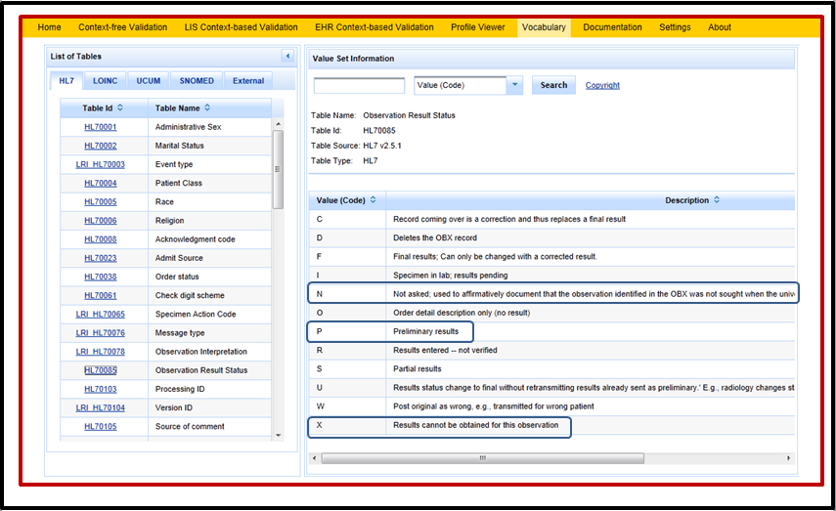

Figure 28. Message Content Data Sheet Showing the "CWE" Value Type as Test Fixed Data for OBX.2 (Not Applicable for Context-free Validation)

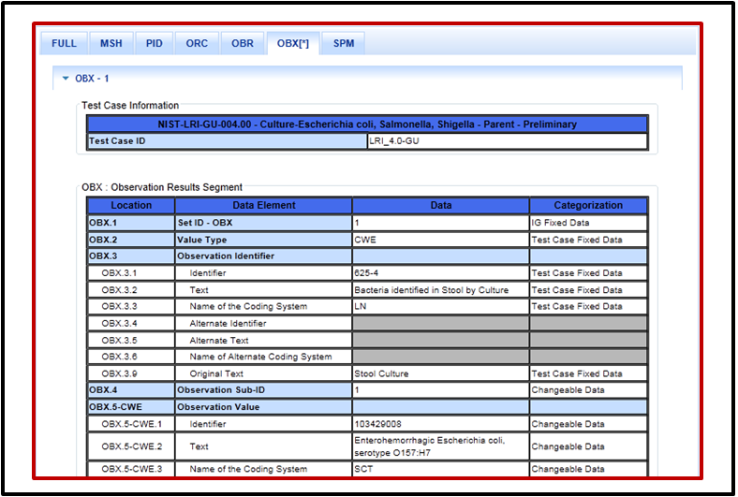

Figure 29. Using the LRI Vocabulary Page to Look Up the Value Codes for Table 0125

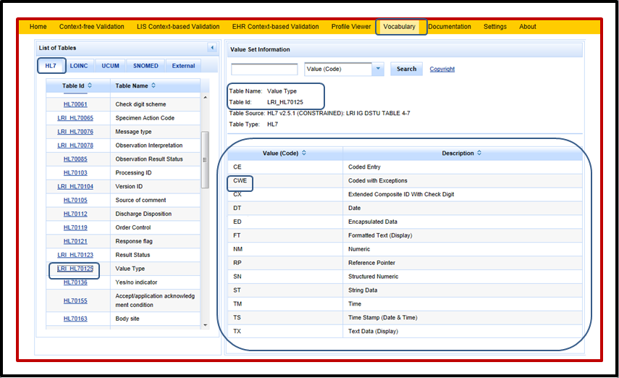

## Example 9: Reading the “Message Structure” Error Notification in the LRI-LIS Context-based Validation or LRI Context-free Validation When a “Conformance Statement” Rule Applies

**Figure 30** shows an example of how the LIS Context-based Validation and LRI Context-free Validation displays error notification information for an invalid LRI message in which data values for data elements in two different Segments are not aligned in accordance with a Conformance Statement in the implementation/messaging guide. In this example, ORC.12 (Ordering Provider) and OBR.16 (Ordering Provider) should be populated with the same data values.

Figure 30. "Message Structure" Type Error is Displayed for Invalid Conformance: Message Validation Result and Message Validation Report

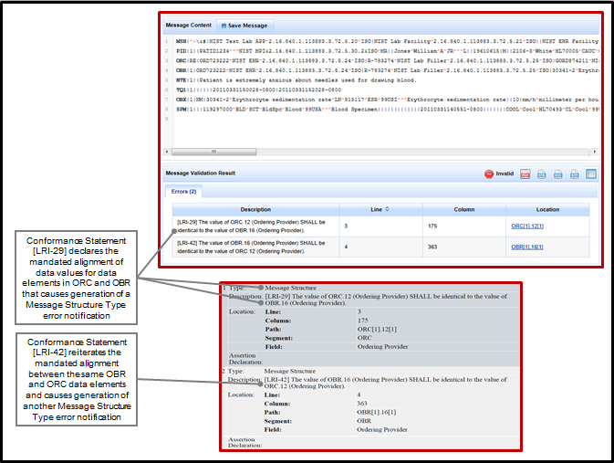

From the information provided in the Message Validation Result and the Message Validation Report, the user can see that

* The data value at Location ORC.12 (Ordering Provider) in the first OBX segment in the message is not the same data value as the one at Location OBR.16 (Ordering Provider), but Conformance Statement LRI-29 mandates that these data values must be the same
* The data value at Location OBR.16 (Ordering Provider) in the first OBR segment in the message is not the same data value as the one at Location ORC.12 (Ordering Provider), but the Conformance Statement LRI-42 mandates that these data values must be the same

To further research the information in these error notifications, the user should open the Profile Viewer to find the Conformance Statements for the ORC.12 and OBR.16 data elements. **Figure 31** illustrates how the LRI Profile Viewer would be used to look up this information for this error when the SUT declares conformance to LRI GU_RN Profile.

The LRI-29 Conformance Statement for ORC.12 states “The value of ORC.12 (Ordering Provider) SHALL be identical to the value of OBR.16 (Ordering Provider).” and the LRI-42 Conformance Statement for OBR.16 states “The value of OBR.16 (Ordering Provider) SHALL be identical to the value of ORC.12 (Ordering Provider).”

Example 9 illustrates another situation in which multiple error notifications are triggered, and by fixing the content in one Location of the message the other error also is resolved.

Figure 31. Using the LRI Profile Viewer to Look Up the Conformance Statements for Misaligned Data Elements

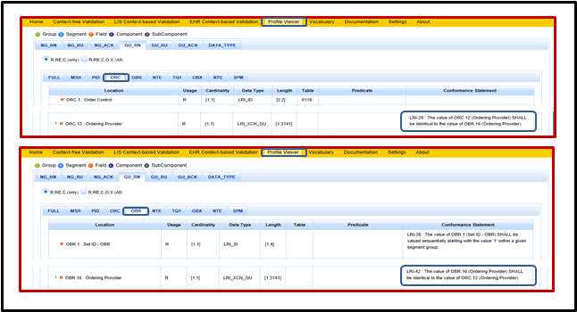

## Example 10: Reading a “Data” Error Notification for Parent-Child Segments in the LRI-LIS Context-based Validation

**Figure 32** shows an example of how the LIS Context-based Validation displays error notification information for an invalid LRI message in which the information in the Parent-Child segments is not aligned.

(Note that the LRI Test Tool program causes both [LRI-33] and [LRI-34] error notifications to be displayed -- if [LRI-33] is triggered [LRI-34] also is triggered automatically and vice versa, even if only one of these error notifications applies. The “Location” information in the Message Validation Result and the “Path” information in the Message Validation Report provide the clue as to whether only one of these error notifications is applicable and, if so, which one it is. In the example in **Figure 32** only [LRI-33] is applicable.)

Figure 32. "Data" Type Parent-Child Segment Error is Displayed: Message Validation Result and Message Validation Report

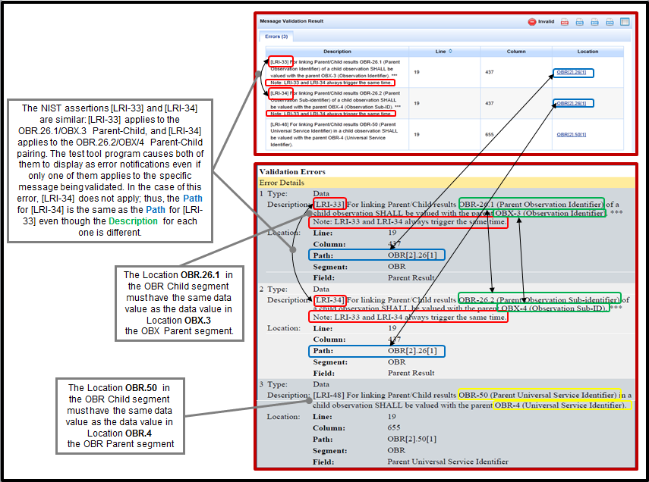

The error notification displays in the Message Validation Result window and on the Message Validation Report; however, the information provided in the Result versus the Report differs slightly, as shown in **Table 8**.

Table 8. Comparison: Message Validation Result vs. Report for "Parent-Child Data” Errors in LRI Test Tool

| **Message Validation Result** | | **Message Validation Report** | |
| --- | --- | --- | --- |
|  |  | Type | Data |
| Description | [LRI-33] For linking Parent/Child results OBR-26.1 (Parent Observation Identifier) of a child observation SHALL be valued with the parent OBX-3 (Observation Identifier). ***  Note: LRI-33 and LRI-34 always trigger the same time. | Description | [LRI-33] For linking Parent/Child results OBR-26.1 (Parent Observation Identifier) of a child observation SHALL be valued with the parent OBX-3 (Observation Identifier). ***  Note: LRI-33 and LRI-34 always trigger the same time. |
| Location | OBR[2]26[1] | Location |  |
| Line | 19 | Line | 19 |
| Column | 437 | Column | 437 |
|  |  | Path | OBR[2]26[1] |
|  |  | Segment | OBR |
| **Message Validation Result** | | **Message Validation Report** | |
|  |  | Type | Data |
| Description | [LRI-34] For linking Parent/Child results OBR-26.2 (Parent Observation Sub-identifier) of a child observation SHALL be valued with the parent OBX-4 (Observation Sub-ID). ***  Note: LRI-33 and LRI-34 always trigger the same time. | Description | [LRI-34] For linking Parent/Child results OBR-26.2 (Parent Observation Sub-identifier) of a child observation SHALL be valued with the parent OBX-4 (Observation Sub-ID). ***  Note: LRI-33 and LRI-34 always trigger the same time. |
| Location | OBR[2]26[1] | Location |  |
| Line | 19 | Line | 19 |
| Column | 437 | Column | 437 |
|  |  | Path | OBR[2]26[1] |
|  |  | Segment | OBR |
|  |  | Field | Parent Result |
|  |  | Field | Parent Result |
| **Message Validation Result** | | **Message Validation Report** | |
|  |  | Type | Data |
| Description | [LRI-48] For linking Parent/Child results OBR-50 (Parent Universal Service Identifier) in a child observation SHALL be valued with the parent OBR-4 (Universal Service Identifier). | Description | [LRI-48] For linking Parent/Child results OBR-50 (Parent Universal Service Identifier) in a child observation SHALL be valued with the parent OBR-4 (Universal Service Identifier). |
| Location | OBR[2]50[1] | Location |  |
| Line | 19 | Line | 19 |
| Column | 655 | Column | 655 |
|  |  | Path | OBR[2]50[1] |
|  |  | Segment | OBR |
|  |  | Field | Parent Universal Service Identifier |

From the information provided in the Message Validation Result and the Message Validation Report, the user can see that the message is invalid because

* The data value in Location **OBR.26.1** of the second OBR segment in the message (the OBR Child segment) does not have the same data value as the data value in Location **OBX.3** (of the OBX Parent segment), and these data values must be exactly the same for Parent-Child segment linking
* Error notifications [LRI-33] [LRI-34] are always triggered together; and even though [LRI-34] does not apply in this specific situation, the LRI Test Tool informs the user about the potentially relevant Predicate requirement: The data value in Location **OBR.26.2** of the second OBR segment in the message (the OBR Child segment) does not have the same data value as the data value in Location **OBX.4** (of the OBX Parent segment), and these data values must be exactly the same for Parent-Child segment linking
* The data value in Location **OBR-50** of the second OBR segment in the message (the OBR Child segment) does not have the same data value as the data value in Location **OBR.4** (of the OBR Parent segment), and these data values must be exactly the same for Parent-Child segment linking

**Figure 33** shows the invalid HL7 Hepatitis Reflex lab results message (GU_RN Profile) that caused the test tool to generate the error notifications. The blue and yellow highlighting indicates the sets of misaligned data values in this message.

Figure 33. Invalid Version of Message with Parent-Child Segments Misaligned

|  |
| --- |
| MSH…  PID…  ORC…  OBR|1|469^Anaheim^2.16.840.1.113883.3.72.5.24^ISO|R-1226546921^Anaheim^2.16.840.1.113883.3.72.5.25^ISO|HepABC Panel^Hepatitis A B C Panel^L^HAVM^Hepatitis A IgM antibodies (IgManti-HAV)^L…  OBX|1|…  OBX|3|…  OBX|4|…  OBX|5|…  OBX|6|…  OBX|7|…  OBX|8|…  OBX|9|SN|48159-8^Hepatitis C virus Ab Signal/Cutoff [Ratio] in Serum or Plasma by Immunoassay^LN^HCVSCO^Hepatitis C antibodies Signal to Cut-off Ratio^L||^10.8|{s_co_ratio}^Signal to cutoff ratio^UCUM^s/co^^L|…  NTE…  ORC|RE|475^Anaheim^2.16.840.1.113883.3.72.5.24^ISO|R-1226847521^Anaheim^2.16.840.1.113883.3.72.5.25^ISO|R-1226847521^Anaheim^2.16.840.1.113883.3.72.5.24^ISO||||||||111111111^Surapaneni^Krishna^Prasad^JR^DR^^^NPI&2.16.840.1.113883.4.6&ISO^L^^^NPI^Anaheim&2.16.840.1.113883.3.72.5.26&ISO^^^^^^^MD||^WPN^PH^^1^123^8971289^11^Hospital Line~^WPN^PH^^1^555^2271234^4^Office Phone|||||||Anaheim^L^^^^NIST sending app&2.16.840.1.113883.3.72.5.21&ISO^XX^^^111|101 ABC^Building 1^FORT WAYNE^IN^46845^USA^L^^42043|^WPN^PH^^1^206^3455231^11^Call 9AM to 5PM|V K^Building 1^ANAHEIM^CA^92801^USA^B^^42043|||||||HepABC Panel^Hepatitis A B C Panel^L  **OBR**|2|475^Anaheim^2.16.840.1.113883.3.72.5.24^ISO|R-1226847521^Anaheim^2.16.840.1.113883.3.72.5.25^ISO|11011-4^Hepatitis C virus RNA [Units/volume] (viral load) in Serum or Plasma by Probe and target amplification method^LN^HCVRNA^Hepatitis C RNA PCR^L|||20140719||||G|||||111111111^Surapaneni^Krishna^Prasad^JR^DR^^^NPI&2.16.840.1.113883.4.6&ISO^L^^^NPI^Anaheim&2.16.840.1.113883.3.72.5.26&ISO^^^^^^^MD||268||||20140719000000-0000|||F|16128-1&Hepatitis C virus Ab [Presence] in Serum&LN&HCVAB&Hepatitis C antibody screen (anti-HCV)&L|||469&Anaheim&2.16.840.1.113883.3.72.5.24&ISO^R-1226546921&Anaheim&2.16.840.1.113883.3.72.5.25&ISO|||||||||||||||||||||HepABC Panel^Hepatitis A B C Panel^L  OBX|1|… |

**Figure 34** shows the corrected and valid HL7 Hepatitis Reflex lab results message (GU_RN Profile). The blue and yellow highlighting indicates the sets of data values that were corrected in this message.

Figure 34. Corrected Version of Message with Parent-Child Segments Aligned

|  |
| --- |
| …  OBR|1|469^Anaheim^2.16.840.1.113883.3.72.5.24^ISO|R-1226546921^Anaheim^2.16.840.1.113883.3.72.5.25^ISO|HepABC Panel^Hepatitis A B C Panel^L^HAVM^Hepatitis A IgM antibodies (IgM anti-HAV)^L…  OBX|1|…  OBX|2|…  OBX|3|…  OBX|4|…  OBX|5|…  OBX|6|…  OBX|7|…  OBX|8|…  OBX|9|SN|48159-8^Hepatitis C virus Ab Signal/Cutoff [Ratio] in Serum or Plasma by Immunoassay^LN^HCVSCO^Hepatitis C antibodies Signal to Cut-off Ratio^L||^10.8|{s_co_ratio}^Signal to cutoff ratio^UCUM^s/co^^L|..  NTE…  ORC|RE|475^Anaheim^2.16.840.1.113883.3.72.5.24^ISO|R-1226847521^Anaheim^2.16.840.1.113883.3.72.5.25^ISO|R-1226847521^Anaheim^2.16.840.1.113883.3.72.5.24^ISO||||||||111111111^Surapaneni^Krishna^Prasad^JR^DR^^^NPI&2.16.840.1.113883.4.6&ISO^L^^^NPI^Anaheim&2.16.840.1.113883.3.72.5.26&ISO^^^^^^^MD||^WPN^PH^^1^123^8971289^11^Hospital Line~^WPN^PH^^1^555^2271234^4^Office Phone|||||||Anaheim^L^^^^NIST sending app&2.16.840.1.113883.3.72.5.21&ISO^XX^^^111|101 ABC^Building 1^FORT WAYNE^IN^46845^USA^L^^42043|^WPN^PH^^1^206^3455231^11^Call 9AM to 5PM|V K^Building 1^ANAHEIM^CA^92801^USA^B^^42043|||||||HepABC Panel^Hepatitis A B C Panel^L^HAVM^Hepatitis A IgM antibodies (IgM anti-HAV)^L  OBR|2|475^Anaheim^2.16.840.1.113883.3.72.5.24^ISO|R-1226847521^Anaheim^2.16.840.1.113883.3.72.5.25^ISO|11011-4^Hepatitis C virus RNA [Units/volume] (viral load) in Serum or Plasma by Probe and target amplification method^LN^HCVRNA^Hepatitis C RNA PCR^L|||20140719||||G|||||111111111^Surapaneni^Krishna^Prasad^JR^DR^^^NPI&2.16.840.1.113883.4.6&ISO^L^^^NPI^Anaheim&2.16.840.1.113883.3.72.5.26&ISO^^^^^^^MD||268||||20140719000000-0000|||F|48159-8&Hepatitis C virus Ab Signal/Cutoff [Ratio] in Serum or Plasma by Immunoassay&LN&HCVSCO&Hepatitis C antibodies Signal to Cut-off Ratio&L|||469&Anaheim&2.16.840.1.113883.3.72.5.24&ISO^R-1226546921&Anaheim&2.16.840.1.113883.3.72.5.25&ISO|||||||||||||||||||||HepABC Panel^Hepatitis A B C Panel^L^HAVM^Hepatitis A IgM antibodies (IgM anti-HAV)^L  OBX|1|… |

# Appendix A

## Types of Error, Warning, and Alert Notifications Generated by the NIST HL7 V2 Test Tools

The NIST HL7 V2 Test Tools are able to generate notifications for the following Errors, Warnings, and Alerts.

* MESSAGE_STRUCTURE: The message structure is broken due to a missing segment, an extra element, violation of a conformance statement, or a misspelled element USAGE: A required element is missing. This type of notification is more precise than the MESSAGE_STRUCTURE but the meaning is the same, i.e., the message structure is broken.
* X-Usage – a data element that is designated as “excluded” is included in the message; an excluded data element is one that SHALL NOT be included in the message.
* W-Usage – a data element that has been withdrawn from the HL7 standard; a withdrawn data element SHALL NOT be included in the message.
* XTRA: An extra element (not defined in the profile) is present.
* CONFORMANCE: A rule described in a conformance statement was not followed
* CARDINALITY: An element is present either a number of times fewer than the minimum cardinality or a number of times greater than the maximum cardinality specified in the profile.
* LENGTH: The length of a value is greater than the maximum length specified in the profile.
* DATATYPE: The value in the message segment is not following the valid expression/format defined by the standard for the datatype listed in the message segment
* DATA: A value does not match a constant specified in the profile or in the provided test data (e.g., IG Fixed Data, Test Case Fixed Data).
* VALUE_NOT_IN_TABLE: The value does not match any of the values in the allowable vocabulary defined for this data element.
* TABLE_NOT_FOUND: The vocabulary named in the message is not defined in the IG for the data element.
* TABLE EMPTY: The existence of the table/value set is known, but there are no values defined in it.
* HUMAN_CHECK: Automated verification of the indicated information in the message cannot be performed by the validation engine, and that this information must be manually inspected by the Tester in order to determine its validity

# Glossary

Component: Fields are populated by data types. Data types may be either primitive or composite specified by the data type. Composite data types are made up of a series of components. CWE-1 (Identifier) is an example of a component.

Field: A field is a string of characters that forms a distinct part of a segment. Fields for use within HL7 segments are defined by HL7 by position element name, length, datatype, Optionality, repetition, and vocabulary constraints. OBX-3 (Observation Identifier) is an example of an HL7 field.

Instance: An occurrence or repetition usually referring to an element that repeats.

Message: A message is the atomic unit of data transferred between systems. It is comprised of a group of segments in a defined sequence. The ORU^R01 message is an example of a message type.

Segment: A segment is a logical grouping of data fields. An example is the OBX segment

Segment Group: Two or more segments may be organized as a logical unit called a segment group. A segment group is assigned a name that represents a permanent identifier. The Order Observation Group is an example of a Segment Group and consists of several segments including the ORC, OBR, OBX, NTE and SPM segments.

Subcomponent: In the case of composite data types, the components of a composite data type component are called sub-components, and they may only be assigned primitive data types.

PID-3.4.1(Namespace ID) is an example of a subcomponent.

SUT: system under test; i.e., the EHR technology being tested using the NIST v2 Test Tool

Usage for Predicates

EVALUATION : 'false' USAGE : C(R/X) – regarding the conditional Usage for the data element (R-Required or X-Excluded), the result of the validation assessment is that the condition for Usage is not met/not supported (false), therefore, the Usage is “X” and the data value MUST NOT be included in the message.

EVALUATION : ‘true’ USAGE : C(R/X) – regarding the conditional Usage for the data element (R-Required or X-Excluded), the result of the validation assessment is that the condition for Usage is mer/supported (true), therefore, the Usage is “R” and the data value MUST be included in the message.